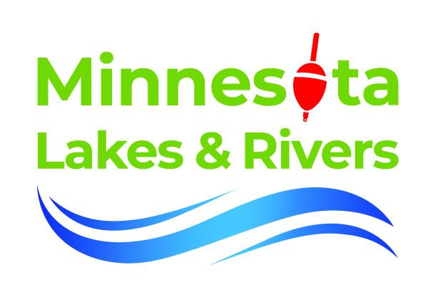
Minnesota’s Fisheries at a Crossroads: Protecting the Future of Our Freshwater Fish

Minnesota holds 5% of the United States’ freshwater, supporting a vibrant fishing tradition and a $4.4 billion industry. But recent research shows our waters—and the fish that live in them—are facing mounting threats. A global study published in Nature in 2024 revealed that one in four freshwater species is at risk of extinction, driven by pollution, invasive species, land-use change, and water extraction

These threats are playing out across Minnesota, where more than half of water bodies are now considered impaired. According to the Minnesota Pollution Control Agency, unhealthy conditions for fish and aquatic life remain the most widespread reason for impairment.

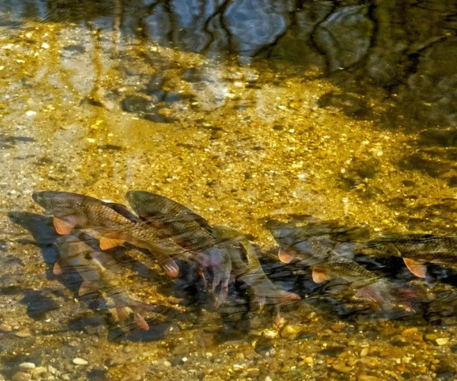
Researchers at the University of Minnesota Duluth have identified a more than 60-year gap since the last major recruitment event in this bigmouth buffalo population
One striking example is the bigmouth buffalo, North America’s longest-living freshwater fish. Researchers at the University of Minnesota discovered a 60-year gap in reproduction, with most fish born before the 1960s. Once dismissed as a “rough fish,” the bigmouth buffalo has been heavily targeted by unregulated bowfishing despite its ecological role. MLR supported the “No Junk Fish” bill, improving protections and mandating more study of undervalued species.
Invasive species further complicate the picture. Zebra mussels, already known for disrupting ecosystems, have now been linked to elevated mercury levels in fish like walleye—up to seven times higher than normal. By altering nutrient flows and fish behavior, they contribute to the formation of toxic methylmercury, increasing risks for fish, loons, eagles, hawks, and people.
Despite these challenges, there are also signs of hope. The Comfort Lake-Forest Lake Watershed District (CLFLWD) is on track to remove five lakes from the impaired waters list by 2026. Their success stems from strong local partnerships, data-driven restoration, and community-led action.
Lake associations have also stepped up. During the COVID-19 pandemic, when agency funding and staffing were limited, local groups supplemented DNR fish stocking efforts. The Lake Miltona Association, for example, has funded the stocking of hundreds of thousands of walleye fingerlings in between 2016 and 2021.
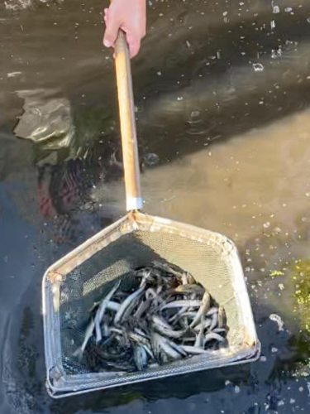
In 2021, the Lake Miltona Association supported the stocking of 35,000 walleye fingerlings
Efforts like these show that local partnerships work—but they need continued support, lake associations capacity grows with resources and support from local and state government. Division and siloing within institutions will limit our collective capacity as a state to preserve the habitat and management of Minnesota’s fisheries. As lawsuits over nitrate pollution and threats to AIS funding emerge, Minnesotans must stay engaged.
The government cannot protect our waters alone. Lake Associations cannot be successful in isolation. MLR builds bridges among the many agencies, local government and civic institutions necessary to successfully advance lake protection and restoration programs. There are over 500 lake associations with an average of 200 members each in the state. By connecting these groups and aligning the resources at the state and local level we can reverse these concerning trends of fish habitat loss.

