Lake Steward: Making Native and Natural the Norm

The land closest to the water is crucial to lake health, yet many lakeshore homeowners are unaware of their impact on water quality, wildlife, and long-term sustainability. Through the Lake Steward Program, Minnesota Lakes and Rivers (MLR) supports lake associations in encouraging property owners to assess and improve their shoreline practices

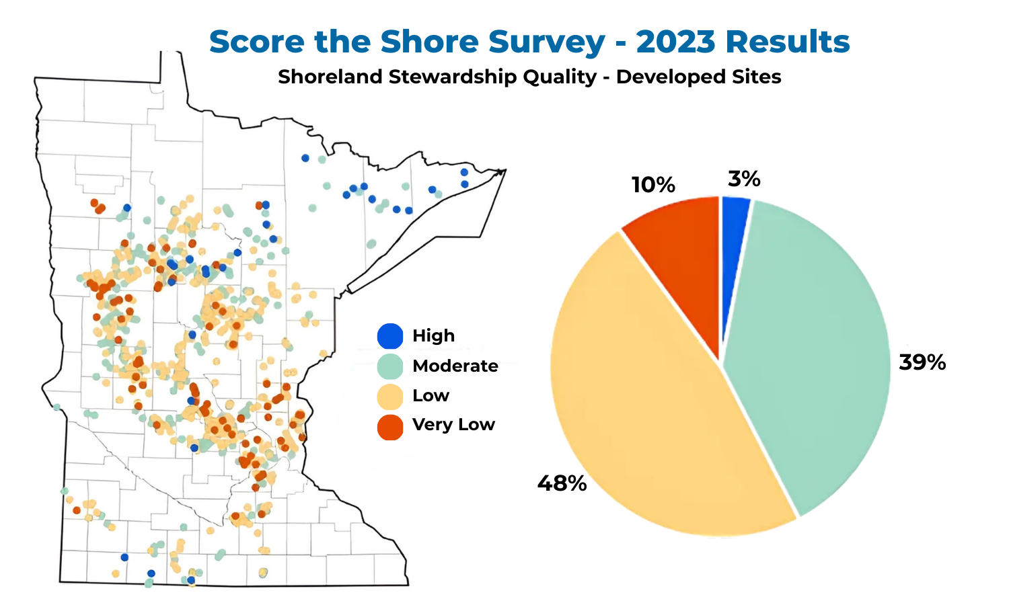
The MN DNR’s Score-the-Shore Survey assesses lakeshore lots in 100-foot increments. Over half of the lots assessed in 2023 were low or very low
Lake Stewards across the state are helping address a growing challenge facing Minnesota’s lakes: the concerning loss of 40–50% of its natural shorelines. Development permits have steadily increased since 2014 and in lake-dense areas like Crow Wing County, population growth has intensified the pressure on these fragile ecosystems. Properties with a "lawn to the lake" generate 10X more runoff and release 9X more phosphorus than vegetated shorelines, leading to algae blooms, declining water quality, and the loss of fish and wildlife habitat.

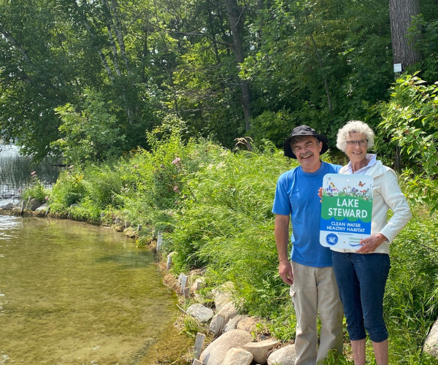
325 property owners were awarded a Lake Steward sign in 2024
Through the Lake Steward program, property owners learn from local experts and neighbors how to restore fish and wildlife habitat and enhance the natural beauty of their shoreline — often with simple no-mow practices or affordable professional guidance. A key part of the program is the "Are You a Lake Steward?" quiz, a short 10-question tool that helps homeowners assess their impact on water quality. After completing the quiz, participants are connected with a Lake Steward Evaluator for personalized recommendations to restore habitat, reduce erosion, and manage runoff. MLR works with both local and state lake ecologists to keep Lake Steward criteria scientifically accurate.

Property owners who meet Lake Steward standards proudly earn a "Lake Steward" sign — a visible symbol of their commitment to protecting Minnesota’s lakes for future generations. In 2024, with 43 lake associations carrying the program statewide, over 200 property owners completed the quiz, and 325 properties received a sign.

Neighborly collaboration in the program helps lake associations build more connected communities. In the north, Steamboat Lake Association’s Lake Stewards planted a pollinator garden at the public access, and Lake Washburn Association hosts an annual Lake Steward Luncheon with a plant giveaway. In north-central Minnesota, Big Pine Lake Property Owners Association has seen membership grow with the expansion of the program. The Gull Chain of Lakes Association also hosted a Native and Natural Bus Tour last summer to celebrate Lake
Stewards, showcase natural shoreline projects, and connect homeowners with restoration experts.

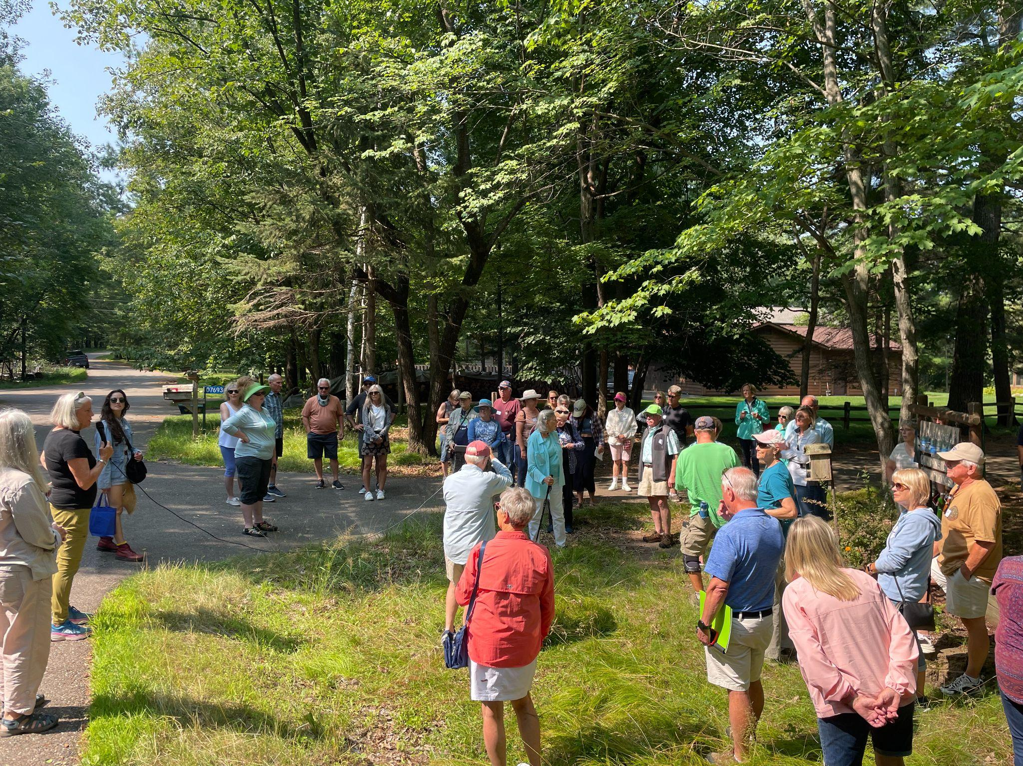 | 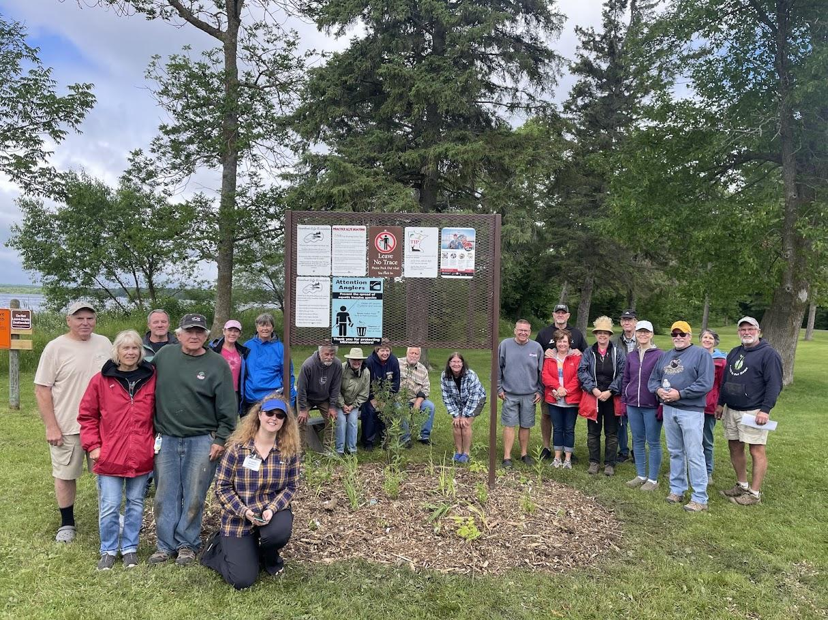
Gull Chain of Lakes Association's Native and Natural Bus Tour highlights the beauty and benefits of natural shorelines, Summer 2024 | 30 volunteers from the Steamboat Lake Association planted native species to thrive in the marshy conditions left by a wet spring.
There has been a surge in public awareness of the need to protect and restore natural shorelines in Minnesota. A 6-part series by MPR News reporter Kirsti Mahrone, titled Trouble by the Water, highlighted the loss of the state’s natural shorelines and the potential for their protection. In August, MLR Executive Director Jeff Forester joined Dorothy Whitmer, co-chair of the Lake Steward Committee for the Gull Chain of Lakes Association, for a special interview on MPR with Angela Davis. They answered questions from the public about shoreline loss and discussed steps people can take to reverse these concerning trends.

As more people recognize the connection between shoreline practices and water quality, the Lake Steward program continues to expand as an essential resource for lake advocates across the state. When individuals make informed choices about shoreline management, the benefits extend beyond their property to the entire lake community. Research shows that once 15% of a population adopts a behavior, it begins to spread organically. As more shoreline property owners commit to protecting their lakes, they help spark a larger culture of stewardship — ensuring the long-term health and sustainability of Minnesota’s treasured waters. Learn more and take the “Are You A Lake Steward?” quiz at https://mnlakesandrivers.org/lake-steward/ Get started with Lake Steward by connecting with Lake Steward Coordinator, Lily Carr lily@mnlakesandrivers.org

