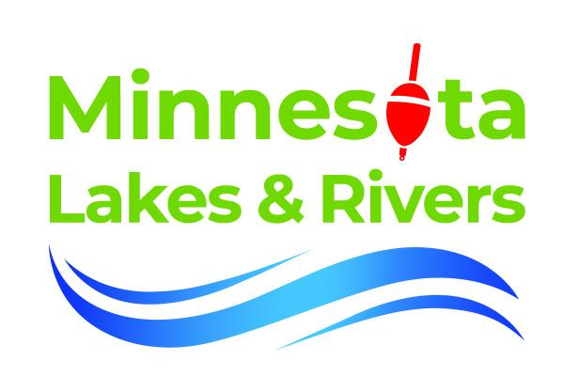
Legislative Update - Minnesota Lakes and Rivers Membership Defies the National Trend of Division

Minnesota Lakes and Rivers, MLR began the session with three areas of focus:

- Increase the Aquatic Invasive Species, AIS, Surcharge on a three-year boat registration to $25 to fund AIS management grants to lake associations, local government units and Tribes.

- Ensure Best Practices, BPs, based on the Saint Anthony Falls Lab study of wake energy be included in the new Boater Education and Certification requirement MLR worked to pass in 2023. BPs include wake surfing at least 500 feet clear of shore and other boaters and in water more than 20 feet deep.

- Provide some relief for shoreline property taxes which have been increasing dramatically in the last few years.

But then two complicated issues emerged. First, budget forecasters estimated that Minnesota would face a $6 billion deficit in FY28-2029. If predicted inflation accelerates and predicted cuts to federal funding occur, the number could be much higher. As a result of this deficit, Gov. Walz’s budget recommendations included a variety of cuts across the government.

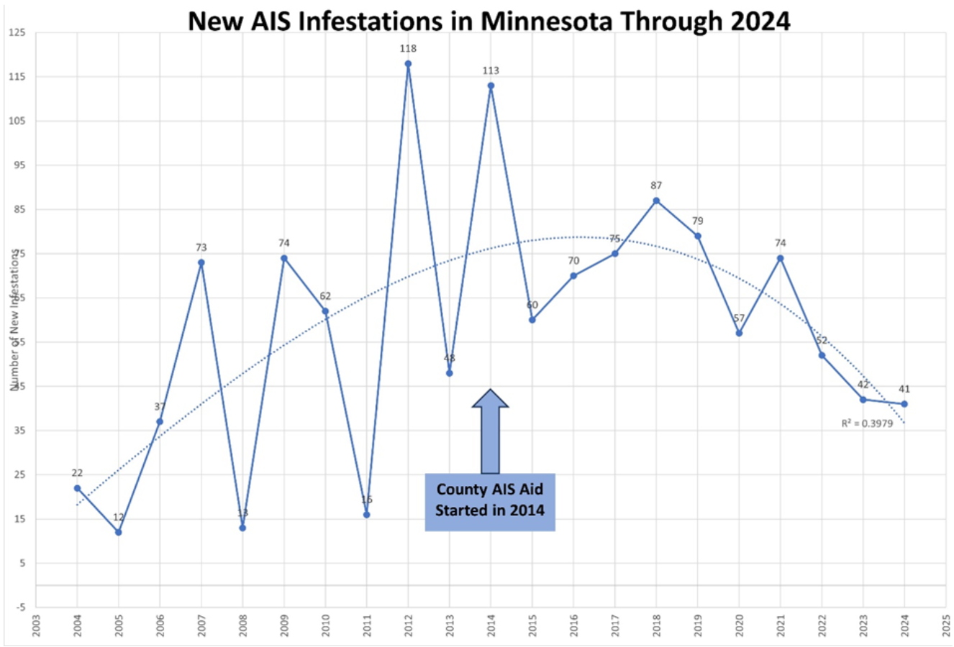
MN DNR data shows the decline in new introductions of AIS in the state since introducing County AIS Prevention Aid in 2014.
One of particular importance to lake folks is the 50% cut to the County AIS Prevention Aid formula MLR worked to pass in 2014. Recognizing that counties and lake associations have a critical role in AIS prevention, the State sends $10 million annually to the counties, apportioned by the number of public boat ramps and watercraft trailer parking spots, for local AIS efforts.

The majority of the AIS inspectors, education, boat cleaning services and grants to lake associations you see out on the lakes comes from this funding source. It has been incredibly effective.

MLR sent out a Citizens Action Network, CAN email encouraging members to write a handwritten letter to Governor Walz asking him to reconsider. CAN users sent over 3,000 emails to state legislators asking them to protect this funding, while MLR lobbyist and Executive Director worked to engage multiple partners including angling groups, conservation groups, Tribal Nations, local government units and County Commissioners. At this writing the legislature is still in session and so it is unclear if our efforts have preserved the County AIS Prevention Aid formula. (If you want to take action go to: https://www.congressweb.com/MLRA/)

Of course, any cuts to local government aid programs by the State government will force a Sophie’s Choice on county governments; they can either cut services, like protecting the lakes, OR raise property taxes. Cuts by Governor Pawlenty and the legislature in the early 2000s led to double digit property tax increases. The same dynamic appears to be setting up now.

MLR is working on solutions to market-driven property tax increases - visit our website for a deep dive into these issues: https://mnlakesandrivers.org/minnesota-property-tax-a-primer/

But the biggest complicating factor of the 94th Legislative Session is that for the first time since 1978, the Minnesota House is equally divided and is operating under a negotiated power sharing agreement between Republicans and Democrats. This has resulted in it being very, very difficult to do anything “new” in the House. For instance, the Senate Environment, Climate and legacy Committee did include the increase in the AIS Surcharge on a three-year boat registration. The House did not.

Division results in a lack of power. Power to adapt, power to advance new ideas, power to organize citizens to action. MLR knows that Water Connects Us All, and it is this unity that brings us power. It is not a unity of homogeneity, but a unity built of diverse political interests that come together to advocate and work for a shared value, healthy lakes and rivers.

MLR is a completely bipartisan organization:
➤ 46% of members lean Republican and 48% lean Democratic. This mirrors the state averages.

➤ MLR membership is almost equally split between urban and rural property owners.

➤ MLR has members in every legislative district in the state, and non-resident members from every state in the union.

➤ The 2024 ballot measure to authorize the Environment and Natural Resources Trust Fund (MLR supported this amendment) passed with over 75% support, polling almost equally in every county in the state.

So, the phrase “Water Connects Us All” is more than aspirational. Clean and healthy lakes and rivers and the family heritage of time spent with family and friends on a waterbody in Minnesota are values that bridge geography and political divides. It is a core value.

Water is our superpower.

Democracy is a system of government that depends on compromise, on coming together to work in collaboration to bring us closer to the common good. Political tension arises when the public good is different for different groups - for instance higher wages versus higher corporate profits.

The public good of clean and healthy lakes largely lacks this tension and most share this value. At a time when there is so much dramatic political division in virtually every aspect of our lives, the need to leave our water resources to our children, grandchildren and great grandchildren is an issue that brings us all together.

MLR’s overarching goal is to build the largest coalition of groups (shoreline property owners, lake associations, angling groups, conservation and outdoor sporting groups, marina and resort owners, and average citizens) into the largest advocacy force in the state. This is political work - non-partisan but political - and it is the appropriate work of the citizen. Join MLR today at https://mnlakesandrivers.org/join/, and add your voice to this rising chorus.

When Water Connects Us All, we have the political power to protect our lakes and rivers for our children, grandchildren and great grandchildren.

