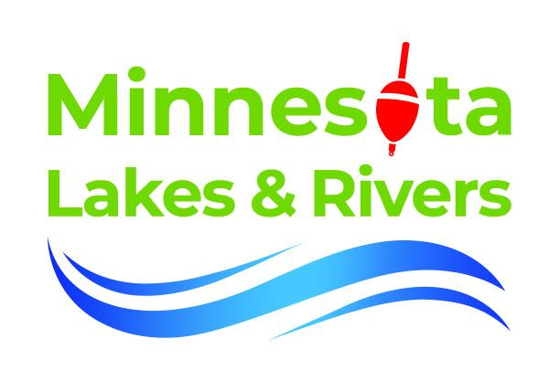
Stop Starry Stonewort: Community-Driven Solutions for Prevention and Management

Since its discovery in Lake Koronis in 2015, starry stonewort (Nitellopsis obtusa) has spread to 31 waterbodies in Minnesota. This aggressive macroalgae reproduces rapidly, posing a significant threat as it forms dense mats in shallow, nearshore waters, crowding out native plants like Chara and southern naiad—critical species for fish habitat and spawning

As these native plants disappear, game fish such as bass, walleye, and muskie struggle to find viable hunting grounds. The recreational impact is equally disruptive, as starry stonewort clogs boat motors, blankets swim beaches, and obstructs public water access. For lake associations, managing starry stonewort after it takes hold is difficult and expensive. Treatments like mechanical harvesting and copper-based algaecides can cost up to $200,000 annually, with limited long-term results.

In 2021, Minnesota Lakes and Rivers Advocates launched the Stop Starry Program to prevent the spread of starry stonewort by addressing a critical gap in boat cleaning practices. While 90% of boaters know to “Clean, Drain, Dry,” only 60% comply due to a lack of access to adequate cleaning tools.
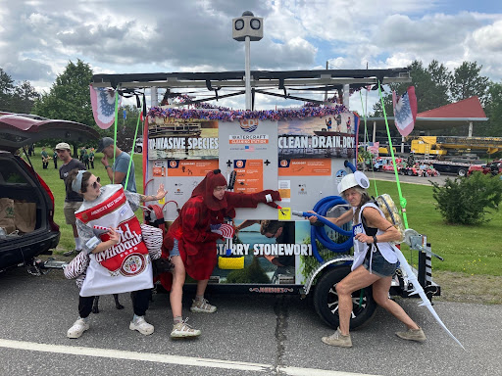
MLR has installed 30 CD3 cleaning stations across 21 different water bodies with Starry Stonewort. Staff and partners collaborate on local and broad outreach.
With support from the Environmental and Natural Resources Trust Fund (ENTRF), a pilot that began with three CD3 waterless boat-cleaning stations in 2021 has grown to 30 stations across 21 waterbodies in 2024, logging over 15,000 uses

In addition to installing tool stations, MLR and its partners have focused on education and public awareness. The program reached hundreds of thousands of Minnesotans through public service announcements, media campaigns, and over 50 outreach events in 2024, including the Minnesota State Fair and the National Loon Center Festival.

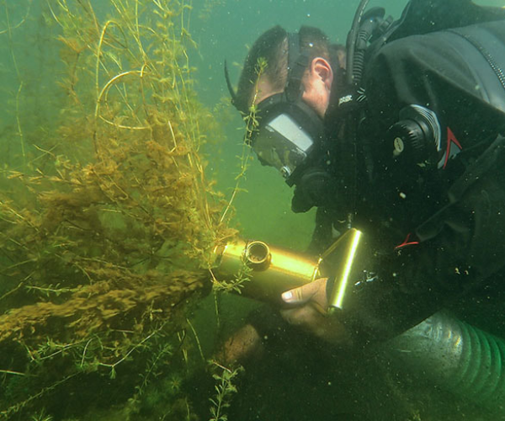
Control strategies like Diver Assisted Suction Harvest, copper algaecide, contained hand-pulling, and biodegradable benthic barriers are all being tested to manage Starry Stonewort
On the treatment side, Stop Starry supports innovative control methods like biodegradable benthic barriers and diver-assisted suction harvesting (DASH). The Leech Lake Band of Ojibwe is also testing drones to locate infestations and studying starry stonewort’s impact on wild rice beds.
Local and state government and academic partners agree Stop Starry complements their AIS management plans while highlighting the value of collaboration with lake associations and Tribal communities.

The success of the Stop Starry Program is its cross-county and community-informed approach. Multiple counties, lake associations, the Leech Lake Band of Ojibwe, and local and state government partners formed a cohesive network of stakeholders committed to AIS prevention. Monthly meetings and annual evaluations allow members to share data, discuss new treatment methods, and coordinate outreach efforts.
Over the past decade, Minnesota has made significant strides in addressing starry stonewort and other aquatic invasive species (AIS) through efforts like County AIS Prevention Aid and MAIRSC’s Starry Trek. While Michigan saw nearly all its inland lakes infested within ten years, Minnesota has kept the number to just 31 known cases. Still, for many residents, that’s 31 too many—especially as infestations creep closer to the state’s busiest boating regions.
The Stop Starry program stands out as a model of regional civic organizing, emphasizing prevention, early detection, and building awareness and local capacity to respond. Minnesota Lakes and Rivers Advocates (MLR) is expanding pilot programs like Stop Starry to protect the health and accessibility of our waters. Supporting MLR through membership helps sustain these efforts for future generations.
Learn more about Stop Starry Stonewort, visit www.mnlakesandrivers.org/stopstarry or contact MLR Associate Director and AIS Lead Organizer, Sami Selter: sami@mnlakesandrivers.org 612-351-1916

