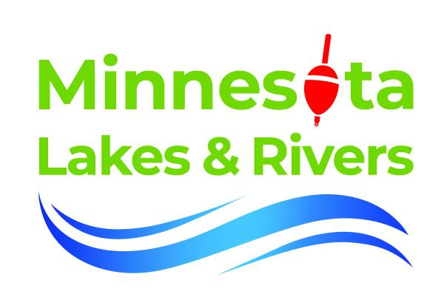
Wake boats are both fun and problematic - Lake Associations can navigate both

Many lake associations are contending with a new issue on their lakes - wake surfing. Wake surfing is the fastest growing segment of the boating industry. Boat builders are designing boat hulls that “plow” the water and use ballast tanks and hydroplanes to drive the stern of boats down into the water. The result is wakes that have the size and energy of Malibu curlers.

It is easy to see why this new sport is so popular. Wake surfing is easy to learn and can be done by multiple generations, making for a great family day on the lake. But the wakes created by these new boats are very, very different from a ski, pontoon, or typical runabout. Because of that energy these wakes have a much greater impact on shoreline, eroding banks and damaging docks, lifts and boats if the wakes hit at full strength.

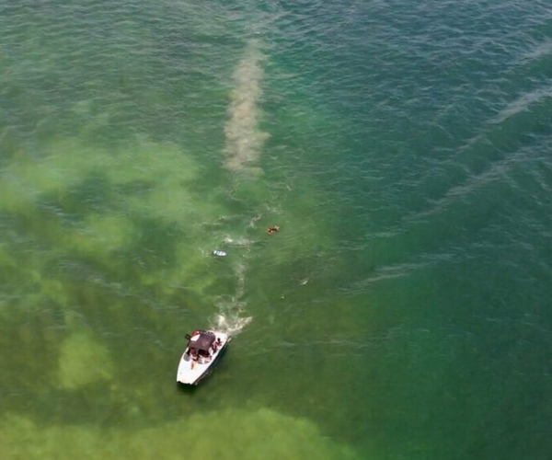
Prop thrust washes at least twenty feet deep, and can disturb lake sediments, uproot native vegetation, and silt over spawning beds.
These large, powerful wakes can make fishing impossible, capsize or swamp canoes, kayaks, paddle boards, rowing skulls and even pontoon boats. Injuries have occurred when other boaters unexpectedly hit a large wake surfing wake.

Simply put, there are problems.

Lake associations are struggling to find a good response. Many of us have spent years trying to bring lake associations together, increase membership, build capacity. Efforts to curb wake surfing, even through local ordinance, threaten to undo this work. Many wake surfing enthusiasts also belong to lake associations. Many have strong community relationships and even discussion of local ordinances to limit wake surfing can drive divisions, particularly in this hypersensitive political climate.

In fact, there is only one lake in Minnesota that has successfully passed an ordinance regulating wakesurfing, Caribou Lake in Cook County. Caribou is in the far north, at the end of the road and no one on the lake owned a wake surfing watercraft when they advanced the ordinance. But this does not mean that we must give up any hope of achieving a solution where the negative impacts are successfully mitigated. It is possible to find a solution that builds political capital, brings the community together in an effort to protect the resource and mitigates controversy.

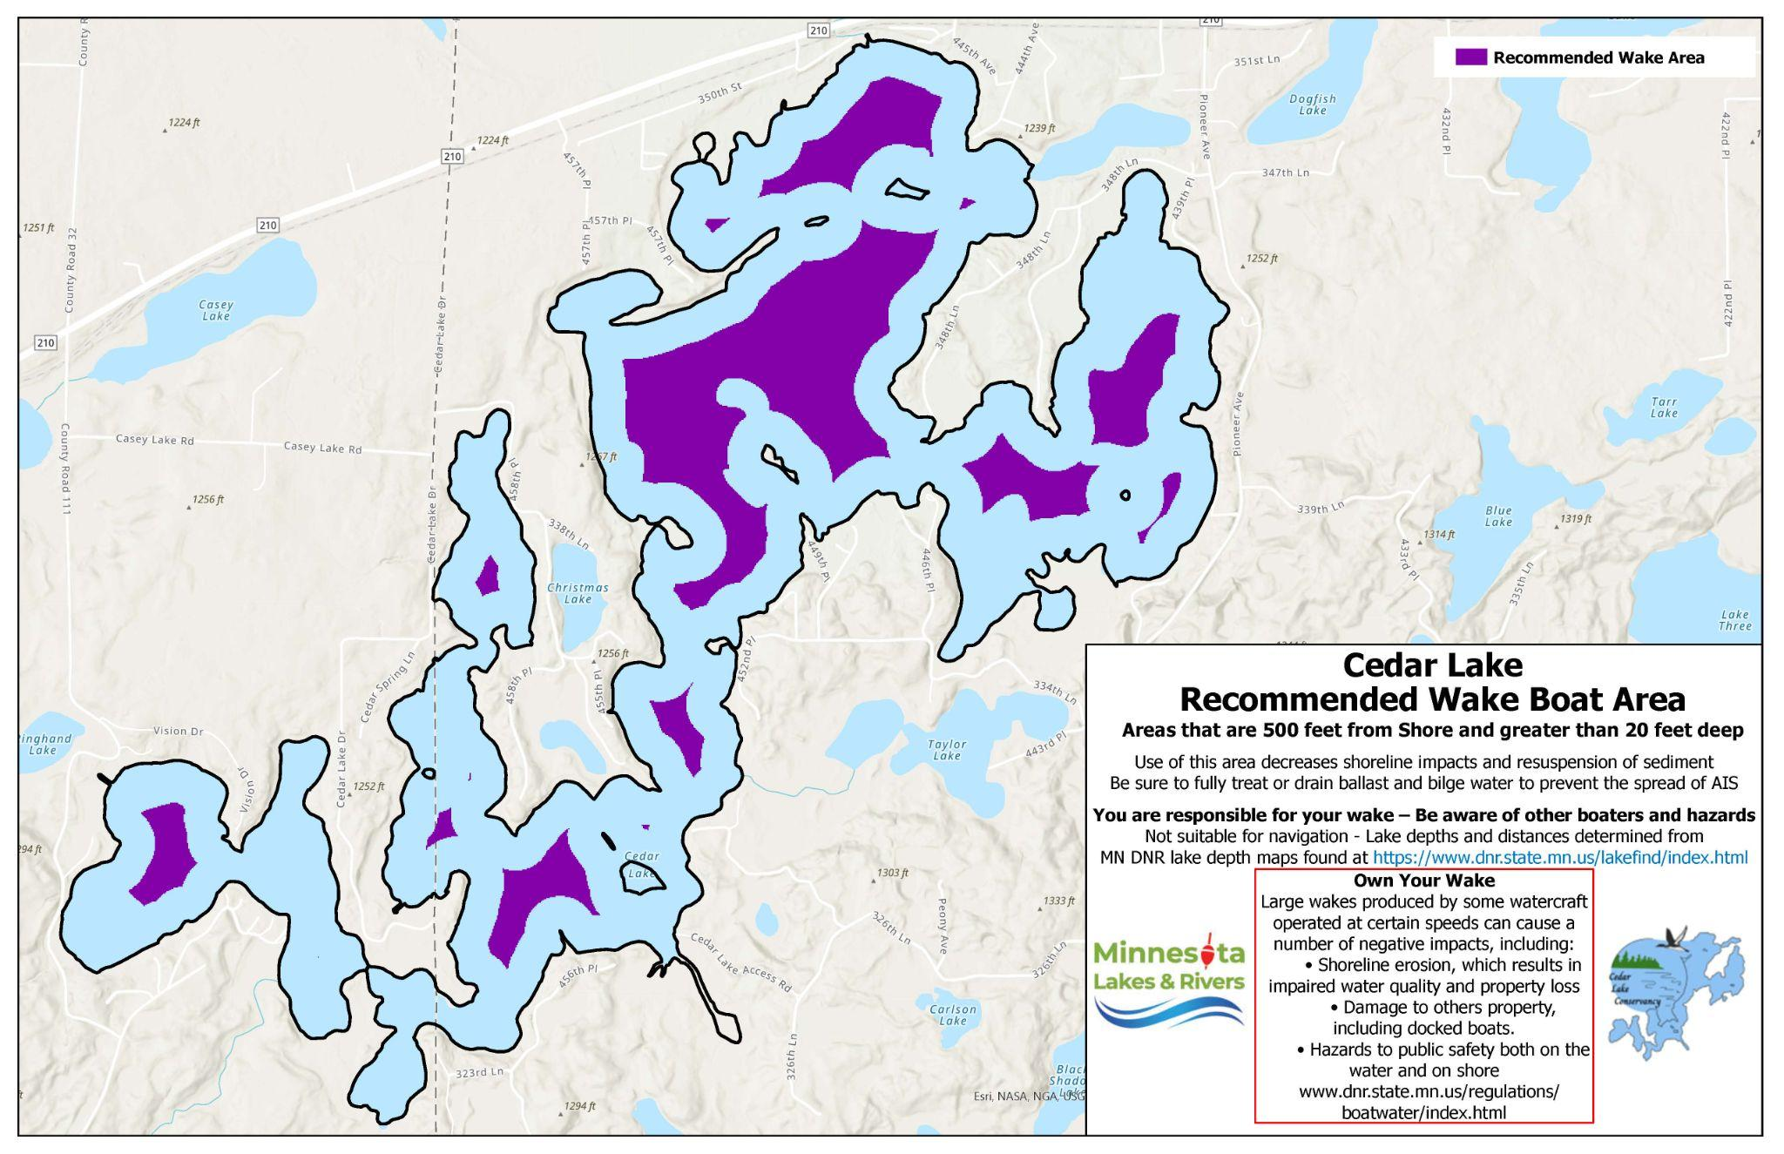
These maps can be distributed to boat owners on the lake and visitors that come.
Minnesota Lakes and Rivers, MLR has followed a three-step process:
➤ Supporting science at the Saint Anthony Falls Lab to determine the wake and prop thrust dynamics and define the specific ecological impacts,

➤ Use this science to draft Best Practices on wake and prop thrust management

➤ Educate all boaters on these Best Practices through a boater education and certification program

As more and more boaters take this course, learn the potential impacts of wake surfing and the Best Practices they can use to minimize these impacts, they will be more and more open to compromise and less susceptible to misinformation. In addition, MLR, has joined with one of our members to offer high quality maps showing areas of the lake that are at least 500 feet from shore and more than 20 feet deep. MLR is also working to raise funding from our lake association partners to put up billboards that further emphasize this message and build on the social pressure to use Best Practices when wake surfing.

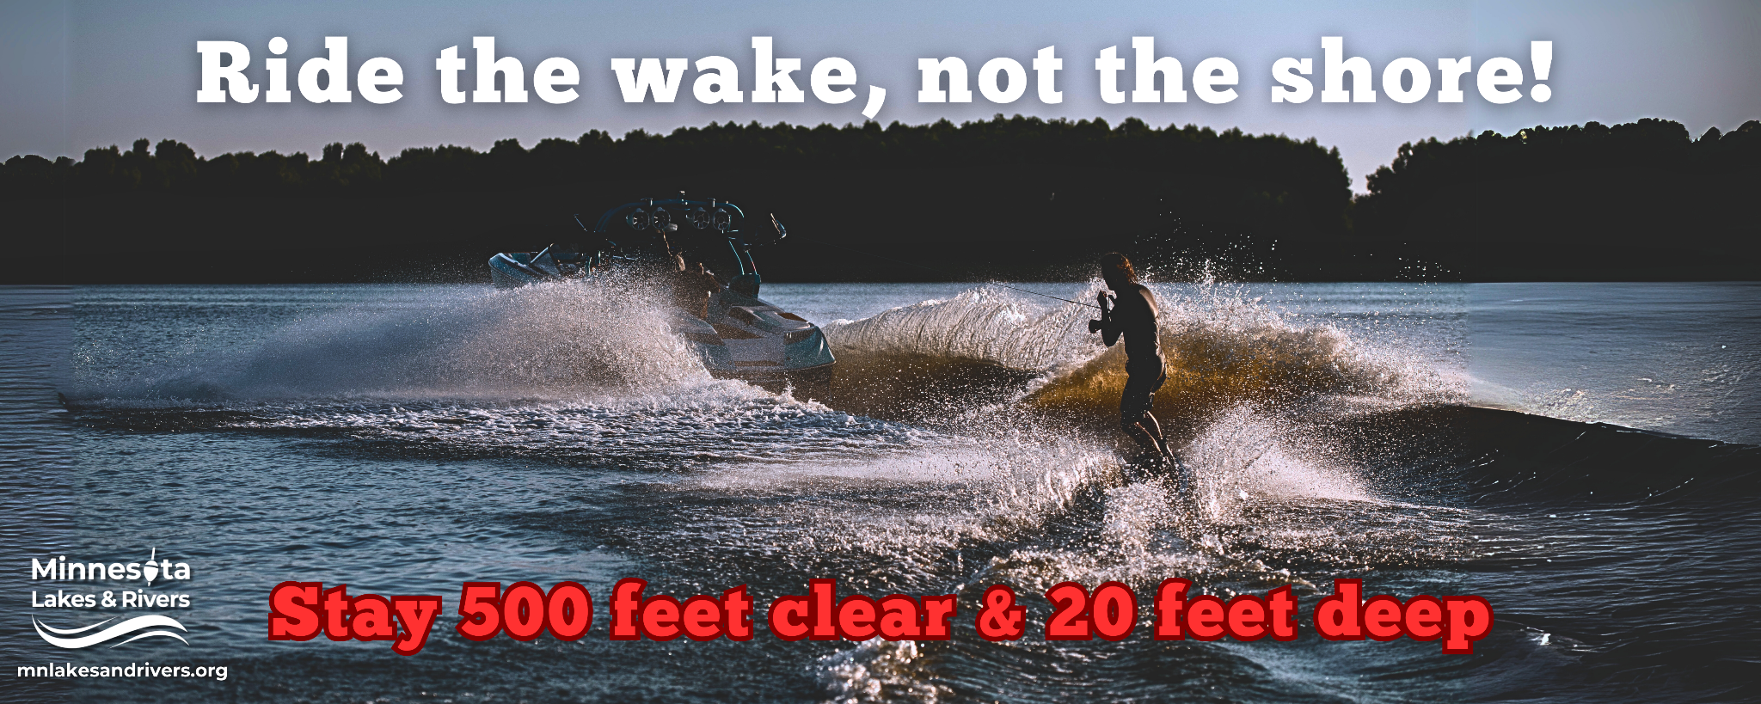
This education and signage at the landing will reinforce the Best Practices message in the training and create social pressure to do the right thing. Using our large network of partners, MLR is working to create a climate where wake surfing can be done without impairing the resource upon which it depends. We want to thank all of you who are working with us in this effort. The right thing.

