From the Desk of Minnesota Lakes and Rivers Executive Director Jeff Forester - Lake Associations Matter

I remember when the Vermilion Lake Association was formed over half a century ago.
In 1968 I was seven years old, and my parents allowed me to travel to Lake Vermilion with my grandmother. I slept on a daybed on her sunporch with all the windows open. The calls of loons and waves washing the round river rock shoreline carried me to sleep and the chatter of chickadees, nuthatches and grossbeaks woke me in the morning.

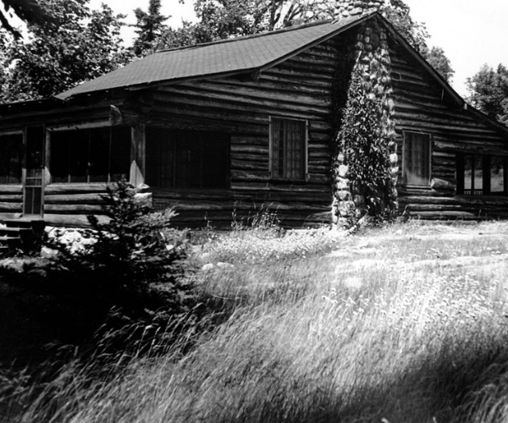
The cabin where it all began — a place of loons, blueberries, and the beginnings of civic commitment that still ripple across Lake Vermilion today
One warm, sun-drenched afternoon she led me into the woods to pick blueberries, showed me how to tilt my tin Folgers can under the bush and rake the berries into it with my fingers. They were smaller and darker purple than store bought, and much more flavorful. That afternoon she taught me how to cut frozen lard into flour to make crust. We baked blueberry pies, saved one for ourselves, and delivered the rest to “old-timers” around town she knew that could no longer pick for themselves due to age or infirmity. One afternoon we took her aluminum boat across the lake to a resort that was hosting a meeting of area leaders. The underground mines had recently closed, and the town’s citizens were meeting to chart a path forward.

I was too young then to track the many ideas raised, the drift and swerve of the conversation, but wandered the tiny island as they day drew later. Now I know that one answer they settled on was all around us - beautiful Lake Vermilion.

Area residents formed the Vermilion Sportsmen’s Club in 1968 to promote tourism to Lake Vermilion from places like Minneapolis, Chicago, Milwaukee, and Iowa.

The Vermilion Lake Association has become the largest civic organization in the area and leads on preventing the spread of aquatic invasive species, fish stocking, setting up shore lunch sites, camping sites and water trails. They do water quality testing, set out navigation buoys, establish “ice roads” in the winter and run a Lake Steward program for which I am a volunteer. They engage with MLR in larger, statewide policy forums including DNR advisory panels, legislative efforts and symposia. They also build a sense of community on Lake Vermilion, a difficult thing on a lake that is over 40 miles long.

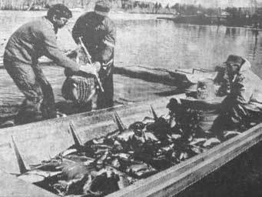
One of the group’s first concerns was rebuilding the walleye population, after the Pike Bay hatchery closed in 1946
Back in 1968, my grandmother and others understood that government cannot protect our resources or revitalize a town that has lost its industry. They recognized that local citizens needed to come together, imagine the community they wanted in the future, and take steps to realize that vision. State or federal government lacks the local knowledge, the urgency, the personal history, the relationships, the civic infrastructure needed to accurately define the problem and craft solutions.

Government can raise funding through levies or other taxes, provide expertise or help lake associations obtain grant dollars. It can use its authority to set standards and issue permits or enforce laws, although all enforcement activity fails if Government does not have the support of the local community.

One day my grandmother took me around to many of the local businesses asking them to put a cardboard display advertising the Vermilion Sportsmen’s Club beside their cash registers. The local paper ran stories about the effort and encouraged people to join.

Our family has been a member ever since. Every summer my wife, daughters and I pick blueberries. We make crust as my grandmother taught me, with frozen lard, pinch of salt and ice water. I volunteer as a Vermilion Lake Association Lake Steward evaluator. I met other property owners, learned their family connection to this place, saw how their values were reflected in the property they stewarded for a time. I enjoy a vibrant local civic infrastructure that my grandmother and other “old-timers” built for the future.

Lake associations develop and protect more than the lake. They create and protect local communities, the relationships built through shared goals and values, what we call Civic Infrastructure. This infrastructure is vital to protecting water. MLR’s primary effort is to use programming, communication and education to link these local communities into a statewide network that creates statewide civic infrastructure to drive the value of clean and healthy aquatic environments.

